IBM CLOUD REGISTRATION

R ABIRAMI

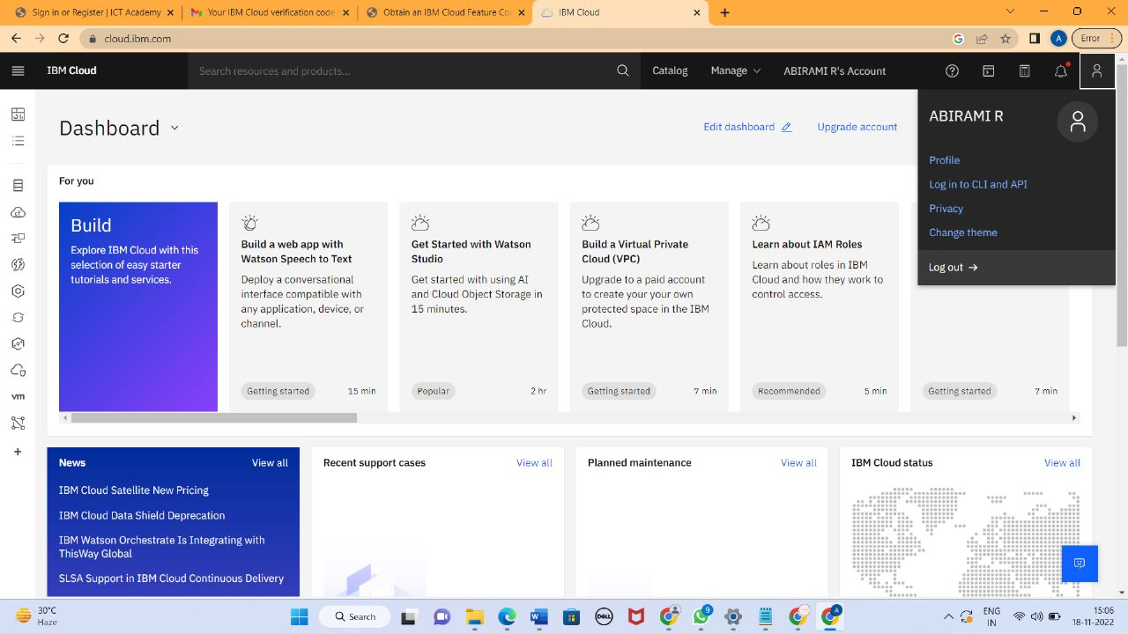

RM GOWTHAMY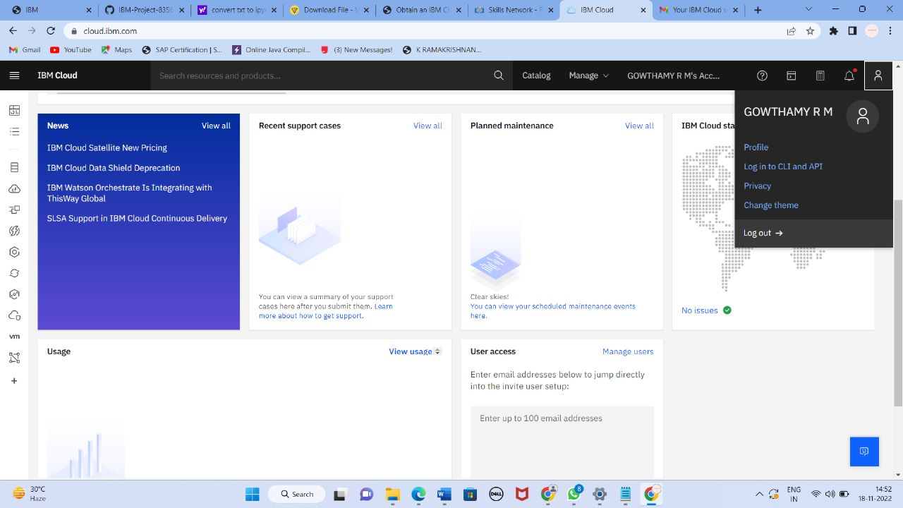

ANGELINE JOY ALEX

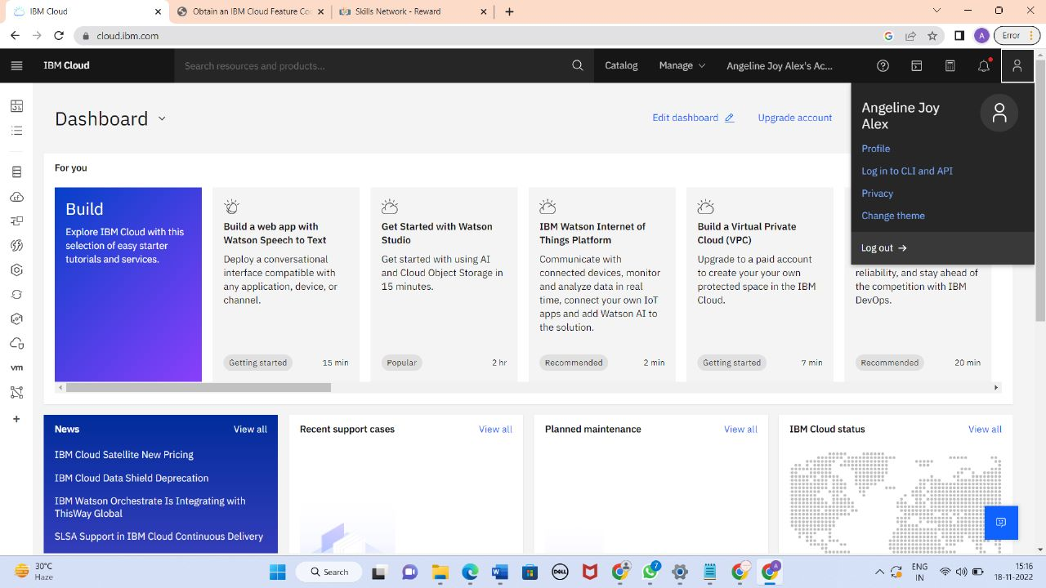

CARLINE IMAKULATE V